***INSTALLATION EXERCISES***

**EXERCISE 4 → Creation and manipulation of snapshots**

For the next exercise we will need to make some snapshots for them to be able to manipulate them later. To make a snapshot we just need to click the button shown below and then click “Snapshots” and then create them whenever we want.

For each snapshot we will need to have something to show us the difference between them, so we will make a file text for each snapshot.

So, starting with the first one, we will start our virtual machine and create a new text file.

After this, we will go to our snapshot window and make a new one from the “Current state” indicator and call it “Initial State”.

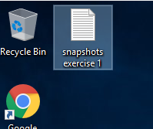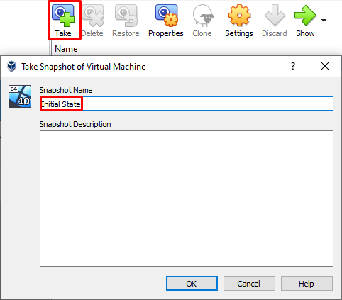

Now, for the next snapshot, we have to make another text file. We have to take into account that at this moment we are in “Initial State” and are changing it into another state by making another snapshot, called “State 2”.

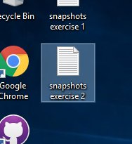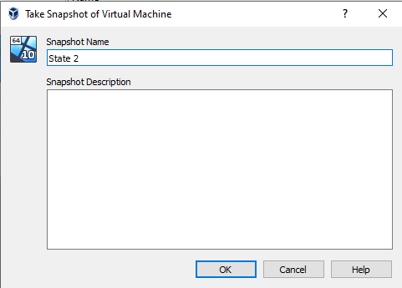

For the third one we will take, we have to create a new text file again and take a new snapshot. This time we are parting from “State 2”, and we are calling the new snapshot “State 2.1”.

This is how all of them should be shown after taking this last one:

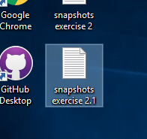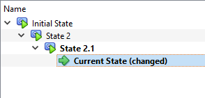

Now we need to shut down our machine and go to our snapshots window. As the exercise asks, we have to restore “State 2”, so we have to click it and press “Restore”, uncheck “Create a snapshot of the current machine state” and restore it.

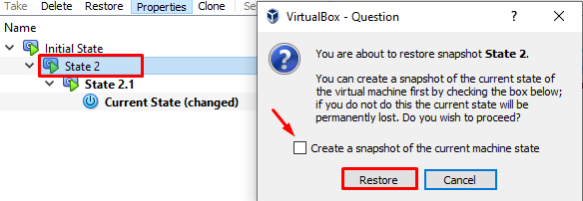

After this, we will start the machine again, create a new text file and, with it, a new snapshot called “State 2.2”.

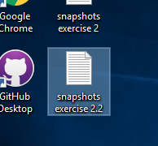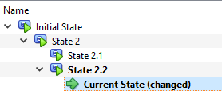

At this point we can answer the questions of the exercise.

For the first one, we need to restore “State 2” (just as the previous process) and delete “State 2.1”.

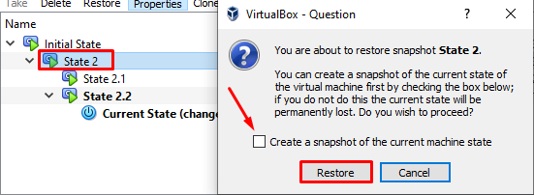

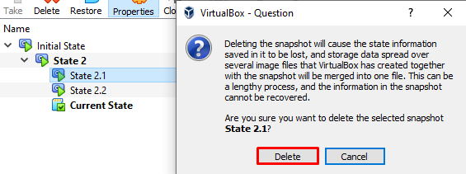

What happens now is that our file from “State 2.1” will have disappeared. We will see it if we start the machine again:

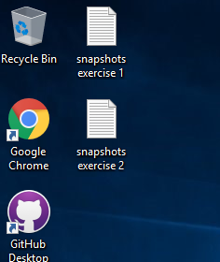

Finally, for the second one, we need to restore “State 2.2” (with the same process as the previous ones) and then delete it.

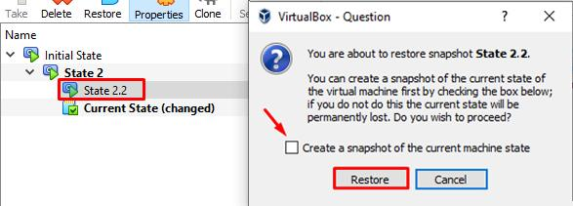

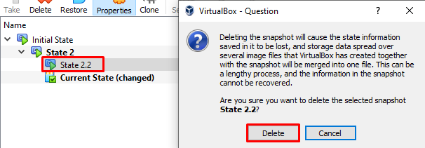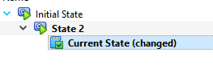

What happens now is that the file we had in “State 2.2” has not been deleted.

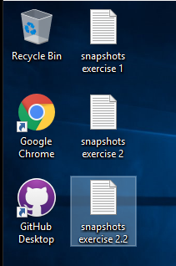

As we said in class, the explanation is that VirtualBox tries to unify every snapshot we take. The thing is that this is only possible for snapshots located in the same branch:

*(As we can see, they are organised in branches)*

This is why the changes done in “State 2.1” were not saved. It was not in the same branch as “State 2” and we also had “State 2.2”, which was even newer, so it stored the information from the “State 2.1”.

**ALFREDO PUERTA GALLEGO DW1E**

**\*\*** I am not sure if these last sentences are correct, as I do not really understand this last issue about State 2.1 and 2.2. If it is wrong or you can give me some advice it would help a lot :)